**Report for HealTalk Mobile Application**

**• Real World Problem Identification**

Mental health is a growing concern globally, with many individuals struggling to find time and resources for self-care. Despite the rising awareness of mental health's importance, there is still a shortage of accessible tools that can help users track their emotional well-being, set goals, and engage in daily self-reflection. Most existing tools are either complex or lack features that encourage users to maintain daily habits of mindfulness.

HealTalk was created to address this gap by offering a simple, user-friendly mobile app that encourages users to engage in daily journaling, track their moods, and set personal goals. By making these features easily accessible, HealTalk helps users incorporate mental wellness into their daily routine without the need for advanced technical knowledge.

**• Proposed Solution**

**HealTalk** is a cross-platform mobile app built with **Flutter**, designed to support users in tracking their emotional states, reflecting through journaling, and achieving personal goals. The app aims to be easy to use, offering a straightforward interface for the following features:

* **Mood Tracking**: A quick and easy way for users to log their daily mood using emojis, helping them recognize patterns in their emotional state.
* **Journal**: Users are provided with a new prompt each day, encouraging them to reflect on their experiences..
* **Goals**: Users can create new goals, track progress using a progress bar, and delete goals once they are completed. The goal list is stored locally, so users can access their goals even when offline.
* **Meditation Sessions**: Simple guided meditation sessions are available with a built-in timer and relaxation tips, allowing users to pause and unwind.
* **Profile Management**: Users can update their name, email through a user-friendly interface, making the app feel personalized.

**• Responsive User Interfaces**

The user interface of HealTalk was designed to be responsive and adaptable, ensuring a smooth experience across various devices. The key screens include:

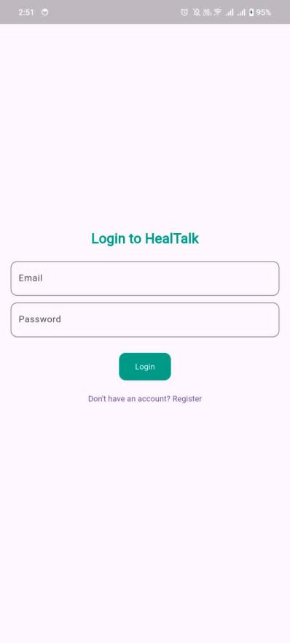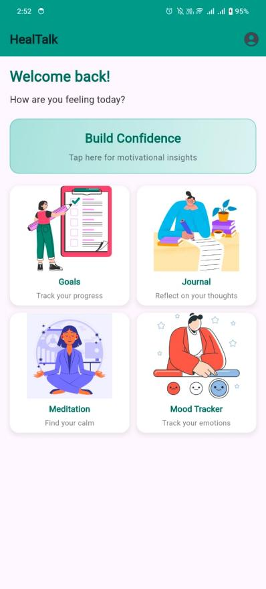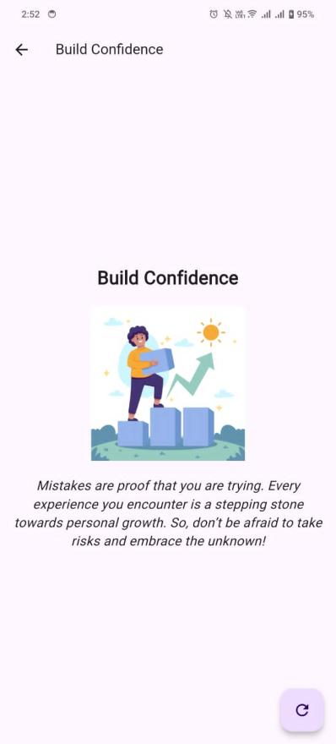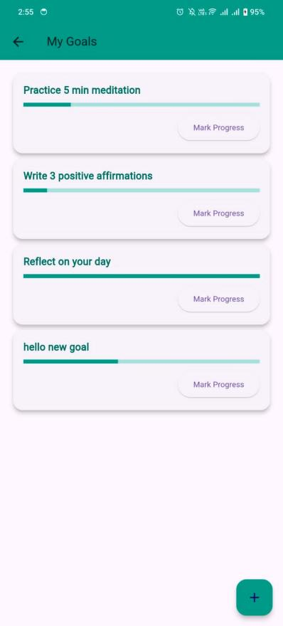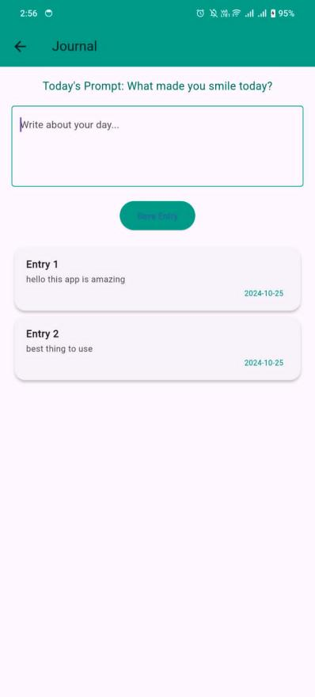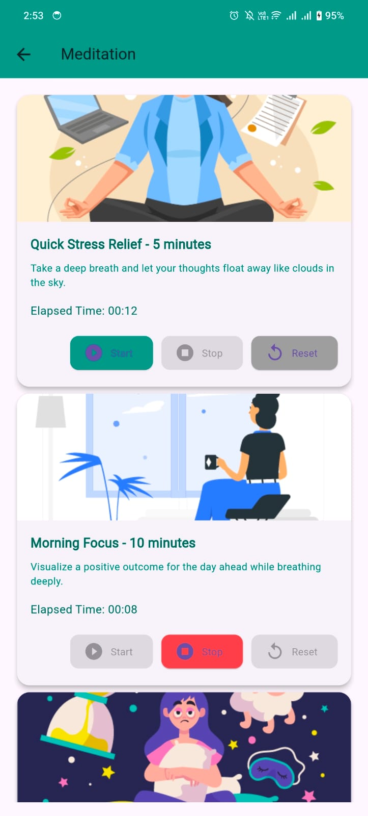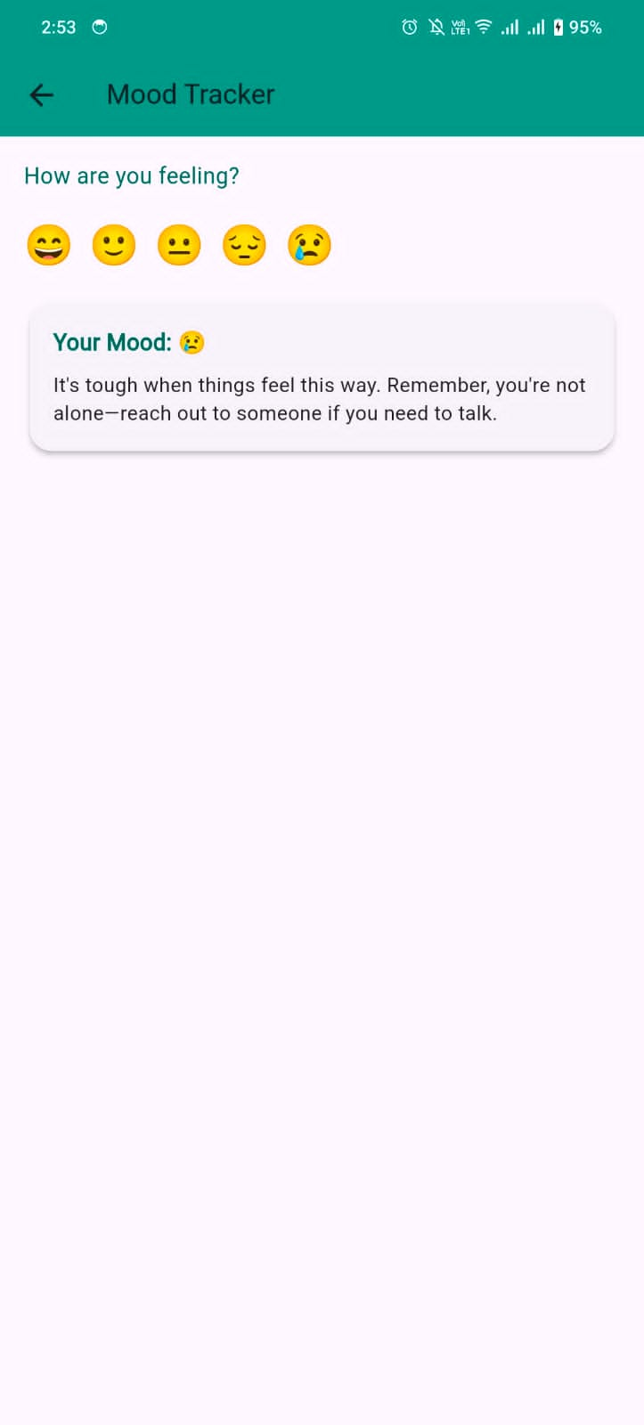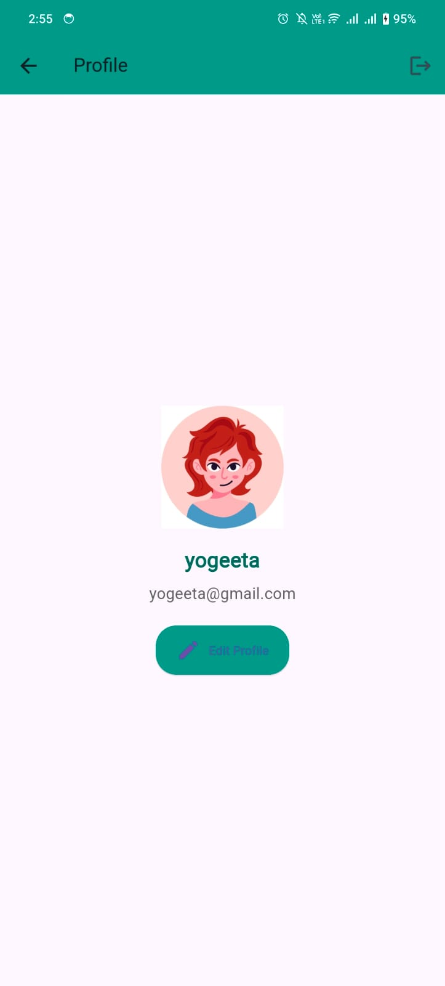

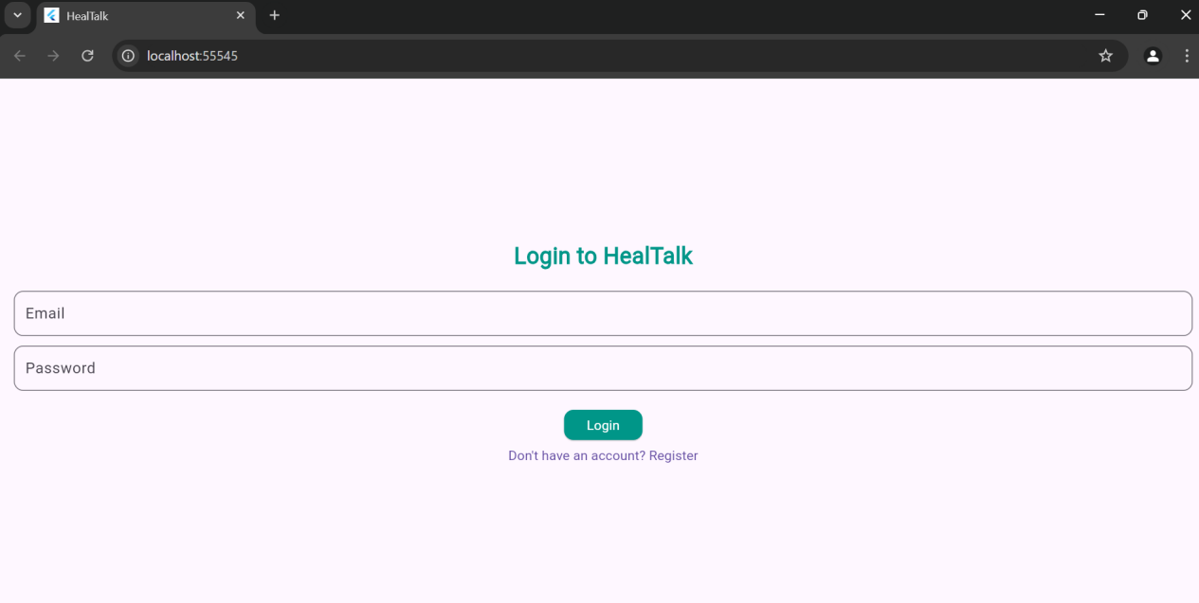

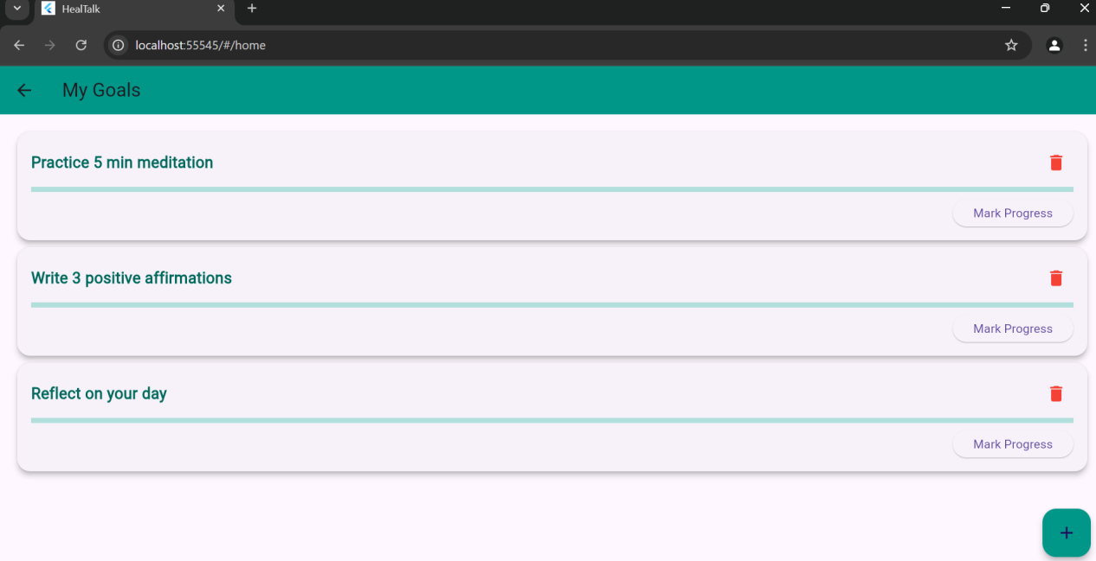

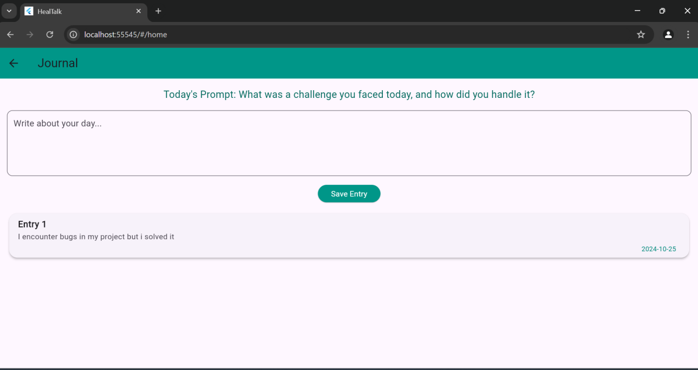

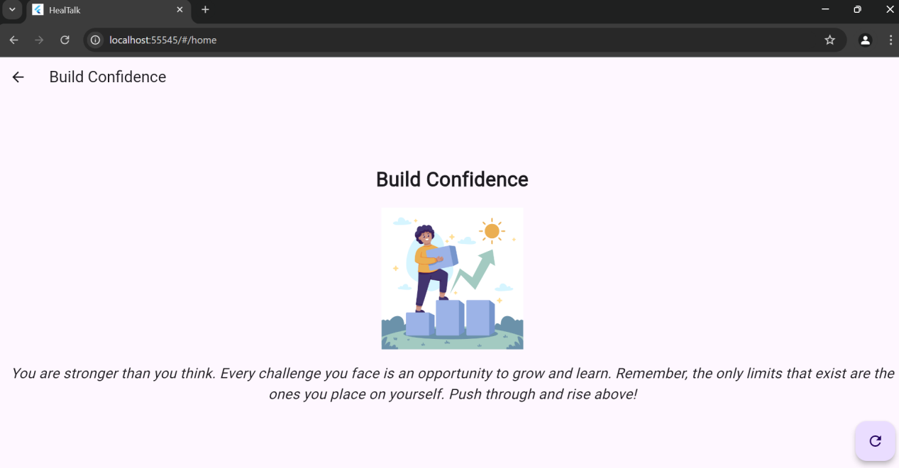

**• Data Storage (With justification for using a particular database)**

HealTalk uses a combination of Firebase Authentication and SharedPreferences for managing user data:

* **Firebase Authentication**: This handles user sign-up and login, ensuring that access to user accounts is secure. Firebase was chosen because of its ease of setup and integration with **Flutter**, making it a suitable choice for secure user authentication.
* **SharedPreferences**: This is used to store journal entries, goals, and mood logs locally on the user's device. This ensures that users have access to their data even when they are offline, making the app more reliable in situations with limited internet connectivity.

**Why SharedPreferences?**

We used Sharedpreferences because it allows for fast reading and writing of small data sets, such as user preferences and daily entries. Since data is stored locally, users can access their saved goals and journals without needing a network connection.

**• Issues and Bugs Encountered and Resolved during Development**

Initially, I noticed that journal entries and goals would disappear when the app was closed and reopened. It turned out that the issue was related to how the data was being saved and retrieved using SharedPreferences. To fix this, I adjusted the data loading sequence in the initState() method, ensuring that data was properly loaded when the screen initialized.

Another issue was an alignment problem with the profile screen, where the profile picture and user information appeared off-center on larger devices. After experimenting with various Alignment properties and using a Center widget, I managed to ensure that all elements were properly centered, creating a more visually appealing layout.

Also Setting up Firebase Authentication was more challenging than expected. I encountered issues with the app not recognizing the Firebase project initially. After going through the Firebase documentation thoroughly and checking my configuration files, I was able to resolve the issue and get the authentication flow working correctly.

Another bug appeared when adding the delete option for goals. At first, deleting a goal caused an error because the list wasn't being updated correctly after a goal was removed. I fixed this by making sure that after a goal was deleted, the updated list was saved using SharedPreferences and the UI was refreshed with setState().

**Conclusion:**

HealTalk successfully combines the simplicity of local data storage with a responsive design to create an engaging user experience. The app provides users with tools to reflect on their mental well-being through daily journaling, track emotional trends with mood logs, and work towards personal goals.

By using Flutter for cross-platform support and Firebase Authentication for secure login, HealTalk is a versatile solution for anyone looking to improve their mental health.